WEEK 4 Day 1- 26 october (Monday)
Demo notes and basic amazon app assignment
Demo notes-ROUTE PROTECTION
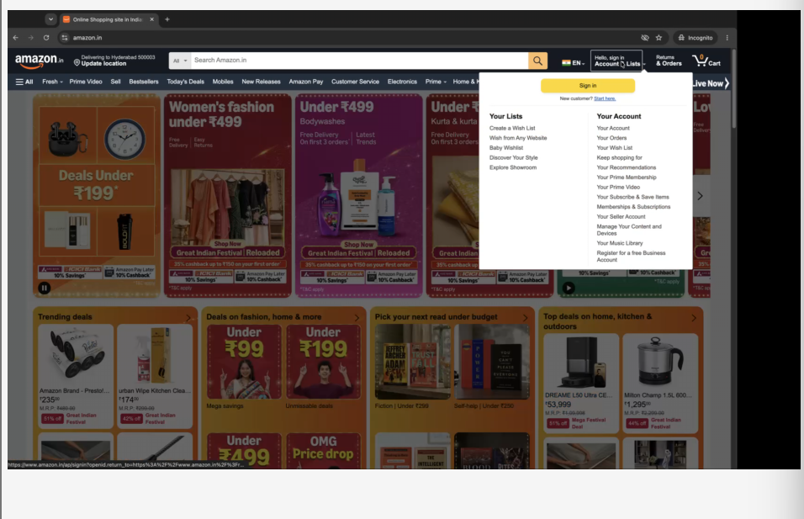
Can search for products(desc, add the item to cart,can go to the cart) without logging in
Cannot buy without logging in—will throw to sign in page (route protected, data is protected)
In demo localhost:
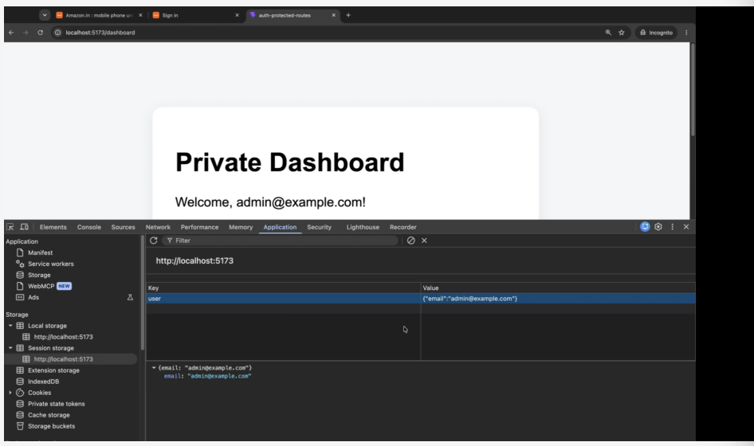
In login, key is not in session
After logging in, its there
CREATING A DEMO PROJECT-VSCODE
npm create vite@latest auth-protected-routes -- --template react
cd auth-protected-routes
npm install
npm install react-router-dom
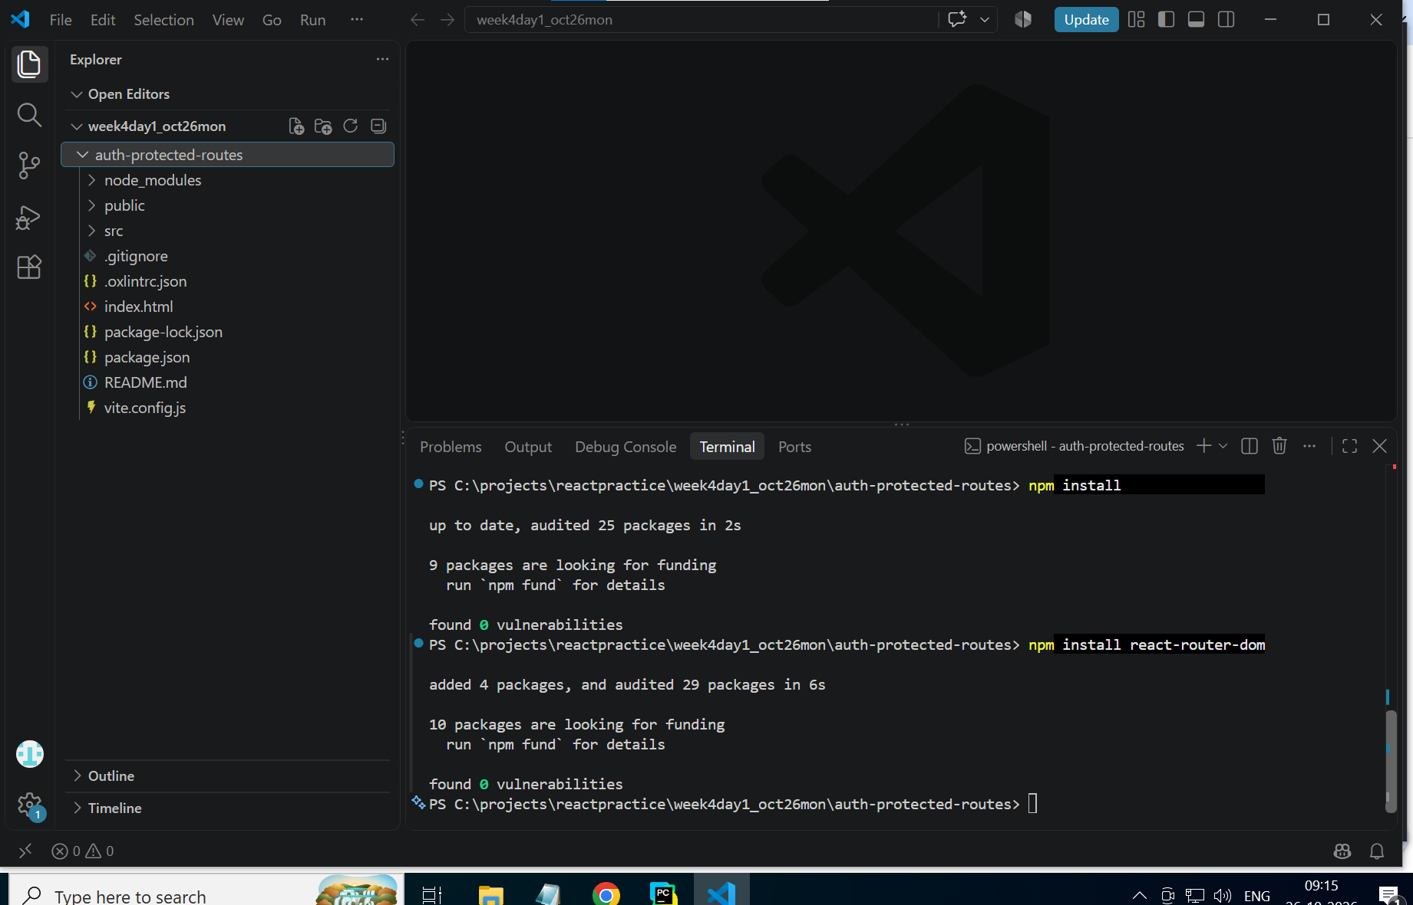
Context api- style of saving the state of the application(context)
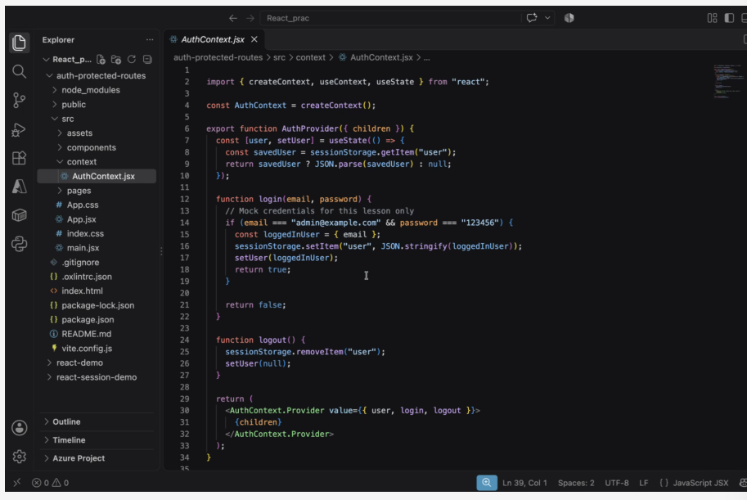
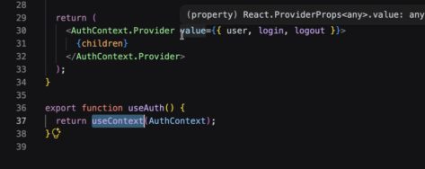
If (email… line-irl would be replaced by db retrieval method
Line 29 return----verifies that session storage, context(checks if present in memory), remaining poages(children) will track what is happening with this page
Line 36 export function useAuth useContext
Hierarchy check:
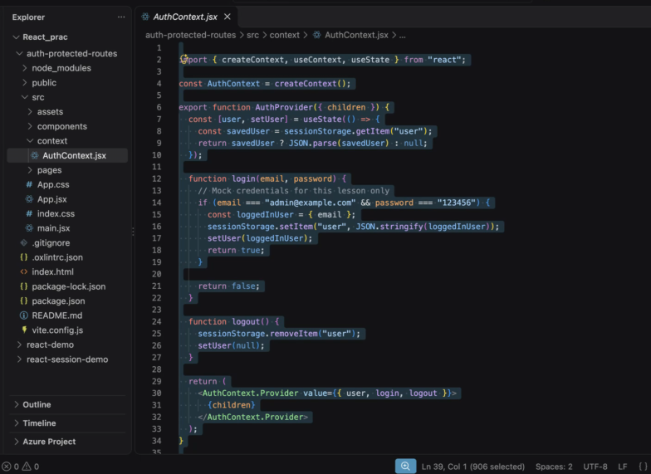
Codeshare: https://codeshare.io/24W4r8
code for AuthContext.jsx:
import { createContext, useContext, useState } from "react";

const AuthContext = createContext();

export function AuthProvider({ children }) {
const [user, setUser] = useState(() => {
const savedUser = sessionStorage.getItem("user");
return savedUser ? JSON.parse(savedUser) : null;
});

function login(email, password) {
// Mock credentials for this lesson only
if (email === "admin@example.com" && password === "123456") {
const loggedInUser = { email };
sessionStorage.setItem("user", JSON.stringify(loggedInUser));
setUser(loggedInUser);
return true;
}

return false;
}

function logout() {
sessionStorage.removeItem("user");
setUser(null);
}

return (
<AuthContext.Provider value={{ user, login, logout }}>
{children}
</AuthContext.Provider>
);
}

export function useAuth() {
return useContext(AuthContext);
}
New folder:
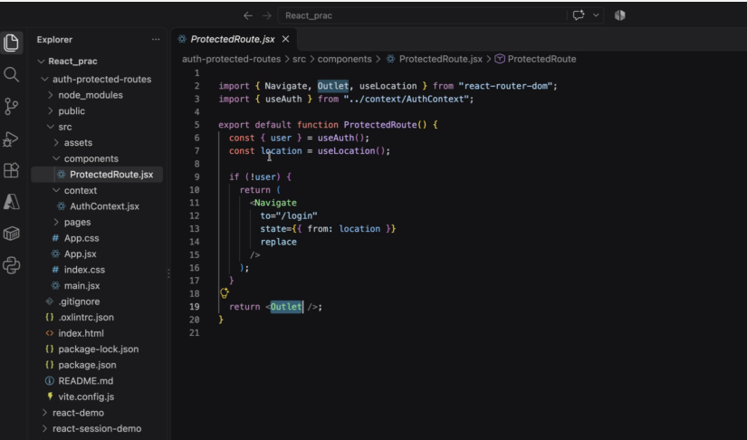
Outlet: if authentication is fine then only you will get the output
<Navigate- to protect the route (/login page here)-throws to login screen if not authenticated
ProtectedRoute.jsx code:
import { Navigate, Outlet, useLocation } from "react-router-dom";
import { useAuth } from "../context/AuthContext";

export default function ProtectedRoute() {
const { user } = useAuth();
const location = useLocation();

if (!user) {
return (
<Navigate
to="/login"
state={{ from: location }}
replace
/>
);
}

return <Outlet />;
}
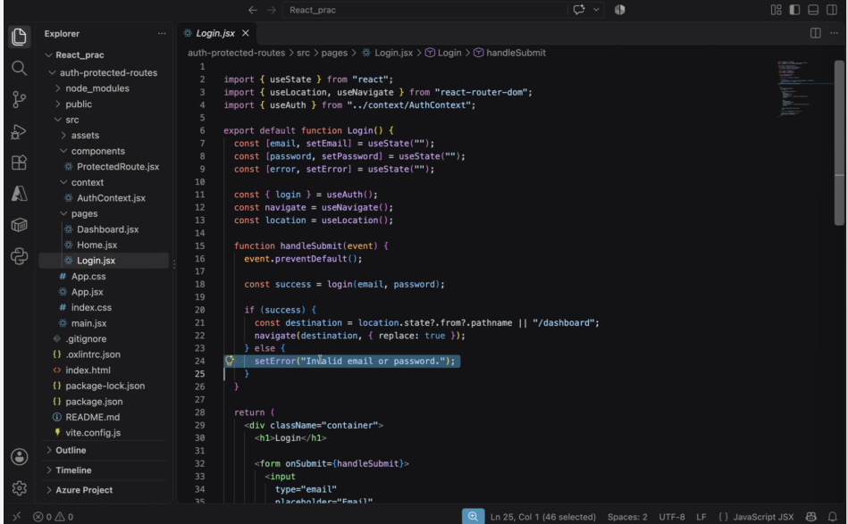
Code for Login.jsx:
import { useState } from "react";
import { useLocation, useNavigate } from "react-router-dom";
import { useAuth } from "../context/AuthContext";

export default function Login() {
const [email, setEmail] = useState("");
const [password, setPassword] = useState("");
const [error, setError] = useState("");

const { login } = useAuth();
const navigate = useNavigate();
const location = useLocation();

function handleSubmit(event) {
event.preventDefault();

const success = login(email, password);

if (success) {
const destination = location.state?.from?.pathname || "/dashboard";
navigate(destination, { replace: true });
} else {
setError("Invalid email or password.");
}
}

return (
<div className="container">
<h1>Login</h1>

<form onSubmit={handleSubmit}>
<input
type="email"
placeholder="Email"
value={email}
onChange={(event) => setEmail(event.target.value)}
required
/>

<input
type="password"
placeholder="Password"
value={password}
onChange={(event) => setPassword(event.target.value)}
required
/>

<button type="submit">Login</button>
</form>

{error && <p className="error">{error}</p>}

<p>Demo email: admin@example.com</p>
<p>Demo password: 123456</p>
</div>
);
}

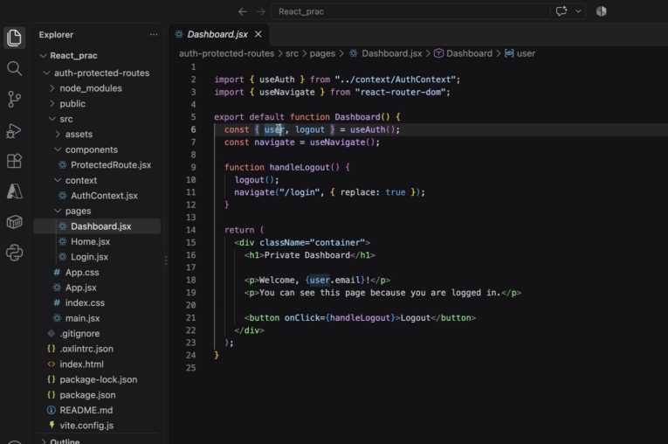
Code for Dashboard.jsx:
import { useAuth } from "../context/AuthContext";
import { useNavigate } from "react-router-dom";
export default function Dashboard() {
const { user, logout } = useAuth();
const navigate = useNavigate();
function handleLogout() {
logout();
navigate("/login", { replace: true });
}
return (
<div className="container">
<h1>Private Dashboard</h1>
<p>Welcome, {user.email}!</p>
<p>You can see this page because you are logged in.</p>
<button onClick={handleLogout}>Logout</button>
</div>
);
}
Code for Home.jsx:
import { Link } from "react-router-dom";
export default function Home() {
return (
<div className="container">
<h1>Authentication Demo</h1>
<p>Learn how React protects private pages.</p>
<nav>
<Link to="/login">Login</Link>
{" | "}
<Link to="/dashboard">Open Dashboard</Link>
</nav>
</div>
);
}

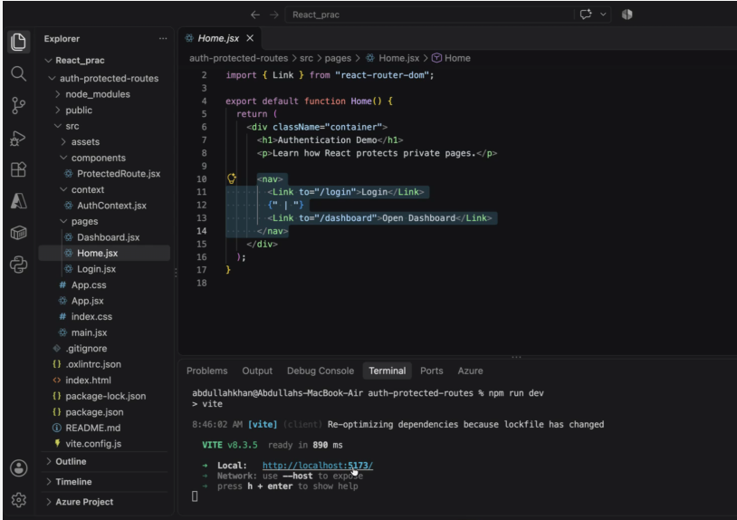
2 links(dashboard, login)
App.jsx code:
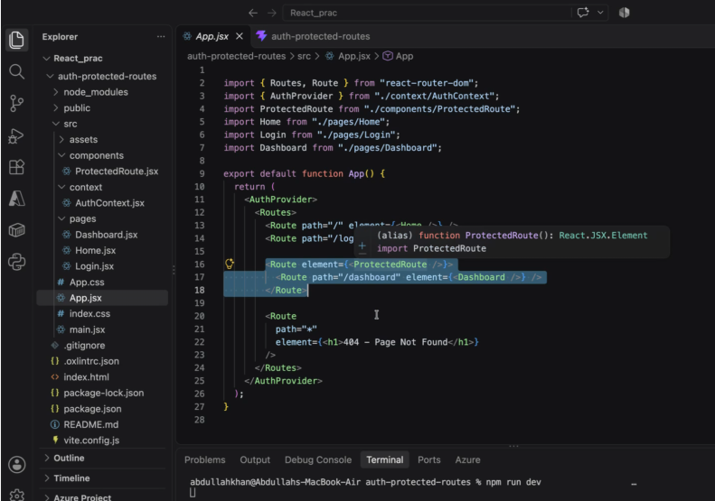

import { Routes, Route } from "react-router-dom";
import { AuthProvider } from "./context/AuthContext";
import ProtectedRoute from "./components/ProtectedRoute";
import Home from "./pages/Home";
import Login from "./pages/Login";
import Dashboard from "./pages/Dashboard";

export default function App() {
return (
<AuthProvider>
<Routes>
<Route path="/" element={<Home />} />
<Route path="/login" element={<Login />} />

<Route element={<ProtectedRoute />}>
<Route path="/dashboard" element={<Dashboard />} />
</Route>

<Route
path="*"
element={<h1>404 - Page Not Found</h1>}
/>
</Routes>
</AuthProvider>
);
}
Code for main.jsx:
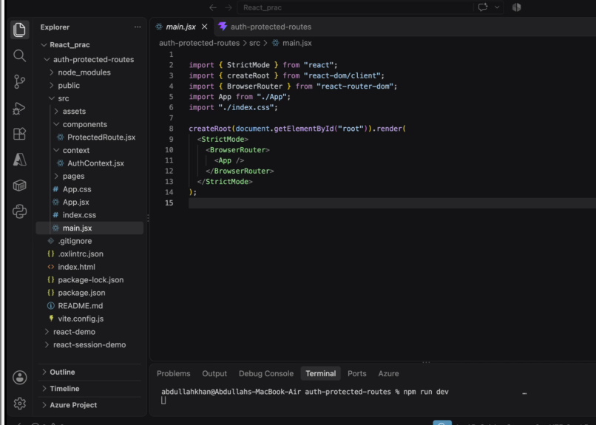

import { StrictMode } from "react";
import { createRoot } from "react-dom/client";
import { BrowserRouter } from "react-router-dom";
import App from "./App";
import "./index.css";

createRoot(document.getElementById("root")).render(
<StrictMode>
<BrowserRouter>
<App />
</BrowserRouter>
</StrictMode>
);
Code for index.css:

body {
margin: 0;
font-family: Arial, sans-serif;
background: #f4f6f8;
}

.container {
max-width: 420px;
margin: 80px auto;
padding: 28px;
background: white;
border-radius: 12px;
box-shadow: 0 4px 16px rgba(0, 0, 0, 0.08);
}

input {
box-sizing: border-box;
display: block;
width: 100%;
padding: 12px;
margin: 12px 0;
}

button {
padding: 12px 18px;
cursor: pointer;
}

.error {
color: #c62828;
}

a {
color: #1565c0;
}
OUTPUT:
Npm run dev
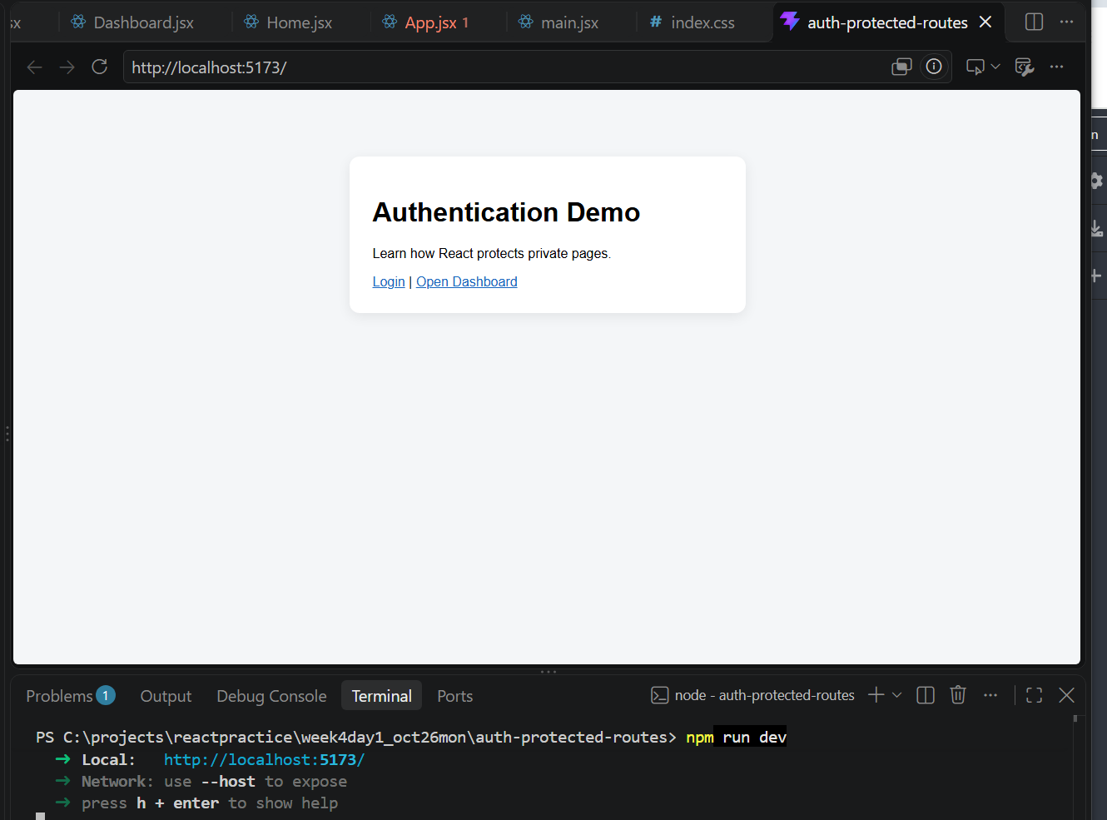
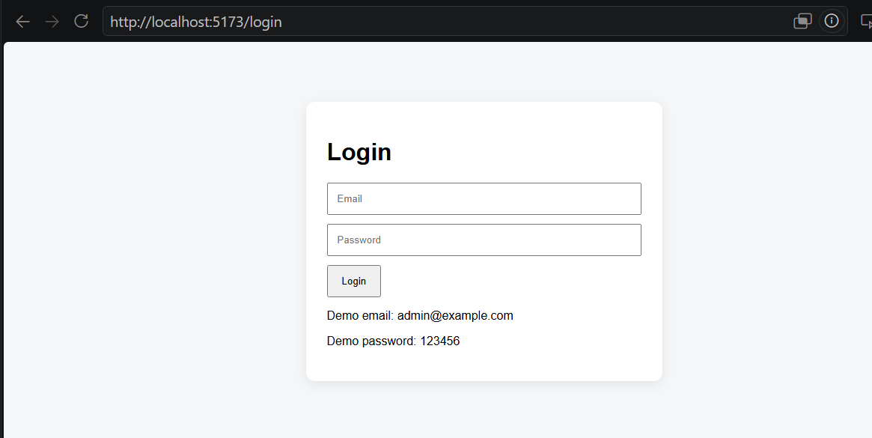
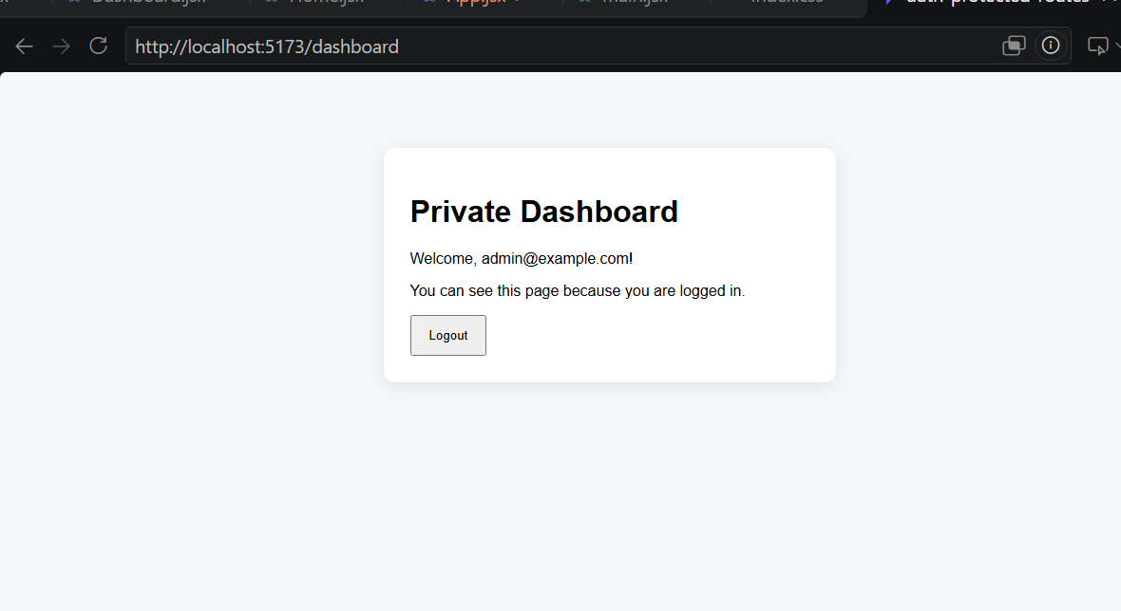

Need to add about page:
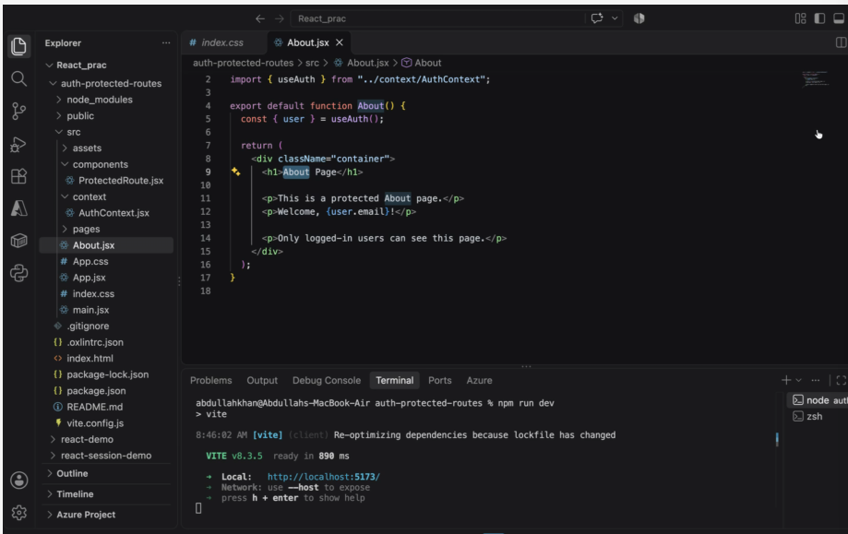
Code for about.jsx:
import { useAuth } from "../context/AuthContext";
export default function About() {
const { user } = useAuth();
return (
<div className="container">
<h1>About Page</h1>
<p>This is a protected About page.</p>
<p>Welcome, {user.email}!</p>
<p>Only logged-in users can see this page.</p>
</div>
);
}
Changes in app.jsx: need to add more protected route (about page)-add link in routing
In codeshare:
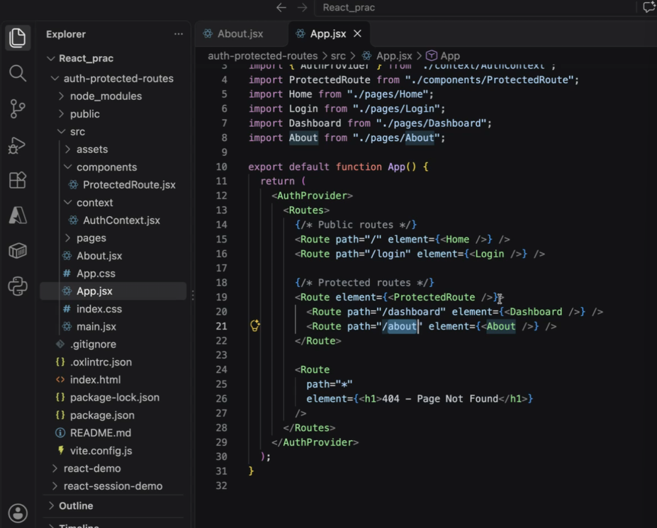
Line 21 added
Modified app.jsx final:

import { Routes, Route } from "react-router-dom";
import { AuthProvider } from "./context/AuthContext";
import ProtectedRoute from "./components/ProtectedRoute";
import Home from "./pages/Home";
import Login from "./pages/Login";
import Dashboard from "./pages/Dashboard";
import About from "./pages/About";

export default function App() {
return (
<AuthProvider>
<Routes>
{/* public routes */}
<Route path="/" element={<Home />} />
<Route path="/login" element={<Login />} />

<Route element={<ProtectedRoute />}>
<Route path="/dashboard" element={<Dashboard />} />
<Route path="/about" element={<About />} />
</Route>

<Route
path="*"
element={<h1>404 - Page Not Found</h1>}
/>
</Routes>
</AuthProvider>
);
}
Changes done to homne.jsx final:
import { Link } from "react-router-dom";

export default function Home() {
return (
<div className="container">
<h1>Authentication Demo</h1>
<p>Learn how React protects private pages.</p>

<nav>
<Link to="/login">Login</Link>
{" | "}
<Link to="/dashboard">Open Dashboard</Link>
{" | "}
<Link to="/about">About</Link>
</nav>
</div>
);
}
OUTPUT :
FINAL:
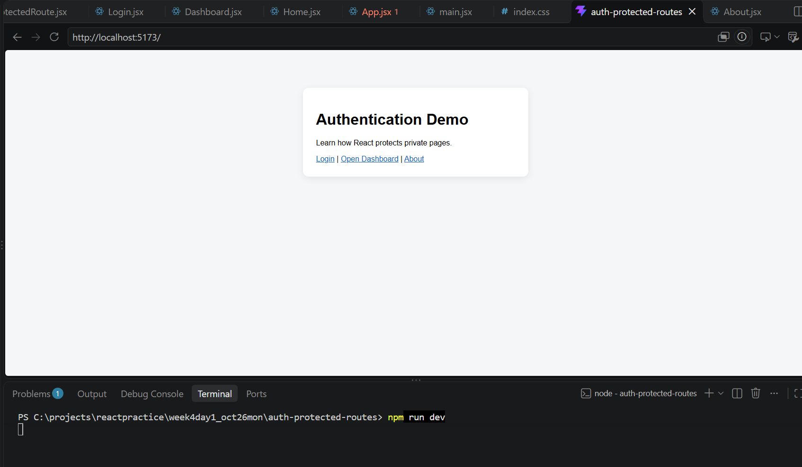

BASIC ASSIGNMENT-AMAZON ON REACT
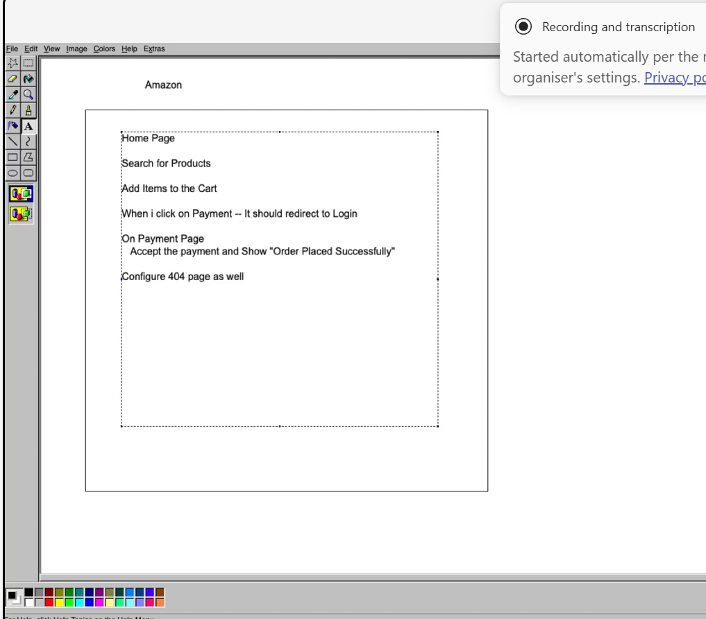
SOLUTION:
STEPWISE CODES:
npm create vite@latest amazon-app -- --template react
cd amazon-app
npm install
npm install react-router-dom
CODE FOR Main.jsx:
import { StrictMode } from "react";
import { createRoot } from "react-dom/client";
import App from "./App";
import "./index.css";
createRoot(document.getElementById("root")).render(
<StrictMode>
<App />
</StrictMode>
);

Code for App.jsx:
import { BrowserRouter, Routes, Route } from "react-router-dom";
import { useState } from "react";

import Navbar from "./components/Navbar";
import Home from "./pages/Home";
import Cart from "./pages/Cart";
import Login from "./pages/Login";
import Payment from "./pages/Payment";
import NotFound from "./pages/NotFound";
import ProtectedRoute from "./components/ProtectedRoute";

function App() {
const [cart, setCart] = useState([]);

return (
<BrowserRouter>
<Navbar />

<Routes>
<Route
path="/"
element={
<Home
cart={cart}
setCart={setCart}
/>
}
/>

<Route
path="/cart"
element={<Cart cart={cart} />}
/>

<Route
path="/login"
element={<Login />}
/>

<Route element={<ProtectedRoute />}>
<Route
path="/payment"
element={<Payment />}
/>
</Route>

<Route
path="*"
element={<NotFound />}
/>
</Routes>
</BrowserRouter>
);
}

export default App;
COMPONENTS TAB
Code for NavBar.jsx :
import { Link } from "react-router-dom";
import "./Navbar.css";
function Navbar() {
return (
<nav className="navbar">
<h2>Amazon</h2>
<div>
<Link to="/">Home</Link>
<Link to="/cart">Cart</Link>
<Link to="/login">Login</Link>
</div>
</nav>
);
}
export default Navbar;

Code for Navbar.css:
.navbar {
background: #232f3e;
color: white;
padding: 15px;
display: flex;
justify-content: space-between;
}
.navbar a {
color: white;
text-decoration: none;
margin-left: 15px;
}

Code for ProtectedRoute.jsx:
import { Navigate, Outlet } from "react-router-dom";
function ProtectedRoute() {
const user = localStorage.getItem("user");
return user ? (
<Outlet />
) : (
<Navigate to="/login" />
);
}
export default ProtectedRoute;
PAGES TAB
Code for Home.jsx:
import { useState } from "react";
function Home({ cart, setCart }) {
const [search, setSearch] = useState("");
const products = [
{
id: 1,
name: "Laptop",
price: 50000,
},
{
id: 2,
name: "Phone",
price: 25000,
},
{
id: 3,
name: "Headphones",
price: 3000,
},
{
id: 4,
name: "Watch",
price: 5000,
},
];
const filteredProducts = products.filter((product) =>
product.name.toLowerCase().includes(search.toLowerCase())
);
const addToCart = (product) => {
setCart([...cart, product]);
};
return (
<div className="container">
<h1>Home Page</h1>
<input
type="text"
placeholder="Search Product"
value={search}
onChange={(e) =>
setSearch(e.target.value)
}
/>
{filteredProducts.map((product) => (
<div key={product.id}>
<h3>{product.name}</h3>
<p>₹{product.price}</p>
<button
onClick={() =>
addToCart(product)
}
>
Add To Cart
</button>
<hr />
</div>
))}
</div>
);
}
export default Home;

Code for Cart.jsx:
import { useNavigate } from "react-router-dom";
function Cart({ cart }) {
const navigate = useNavigate();
const total = cart.reduce(
(sum, item) => sum + item.price,
0
);
return (
<div className="container">
<h1>My Cart</h1>
{cart.length === 0 ? (
<p>Cart is Empty</p>
) : (
<>
{cart.map((item, index) => (
<div key={index}>
<h3>{item.name}</h3>
<p>₹{item.price}</p>
</div>
))}
<h2>Total: ₹{total}</h2>
<button
onClick={() =>
navigate("/payment")
}
>
Proceed To Payment
</button>
</>
)}
</div>
);
}
export default Cart;

Code for Login.jsx:
import { useState } from "react";
import { useNavigate } from "react-router-dom";
function Login() {
const navigate = useNavigate();
const [email, setEmail] =
useState("");
const [password, setPassword] =
useState("");
const handleLogin = () => {
if (
email === "admin@example.com" &&
password === "123456"
) {
localStorage.setItem(
"user",
email
);
navigate("/payment");
} else {
alert("Invalid Credentials");
}
};
return (
<div className="container">
<h1>Login</h1>
<input
type="email"
placeholder="Enter Email"
value={email}
onChange={(e) =>
setEmail(e.target.value)
}
/>
<br />
<br />
<input
type="password"
placeholder="Enter Password"
value={password}
onChange={(e) =>
setPassword(e.target.value)
}
/>
<br />
<br />
<button onClick={handleLogin}>
Login
</button>
</div>
);
}
export default Login;

Code for Payment.jsx:
import { useState } from "react";
function Payment() {
const [success, setSuccess] =
useState(false);
return (
<div className="container">
<h1>Payment Page</h1>
{!success ? (
<button
onClick={() =>
setSuccess(true)
}
>
Place Order
</button>
) : (
<h2>
Order Placed Successfully
</h2>
)}
</div>
);
}
export default Payment;
code for NotFound.jsx:
function NotFound() {
return (
<div className="container">
<h1>404</h1>
<h2>Page Not Found</h2>
</div>
);
}
export default NotFound;
MAIN TAB
Code for index.css:
body {
margin: 0;
font-family: Arial, sans-serif;
}
.container {
width: 80%;
margin: auto;
padding-top: 20px;
}
input {
padding: 10px;
width: 250px;
}
button {
padding: 10px 15px;
cursor: pointer;
background: #ff9900;
border: none;
color: white;
}
button:hover {
background: #e68900;
}
OUTPUT:
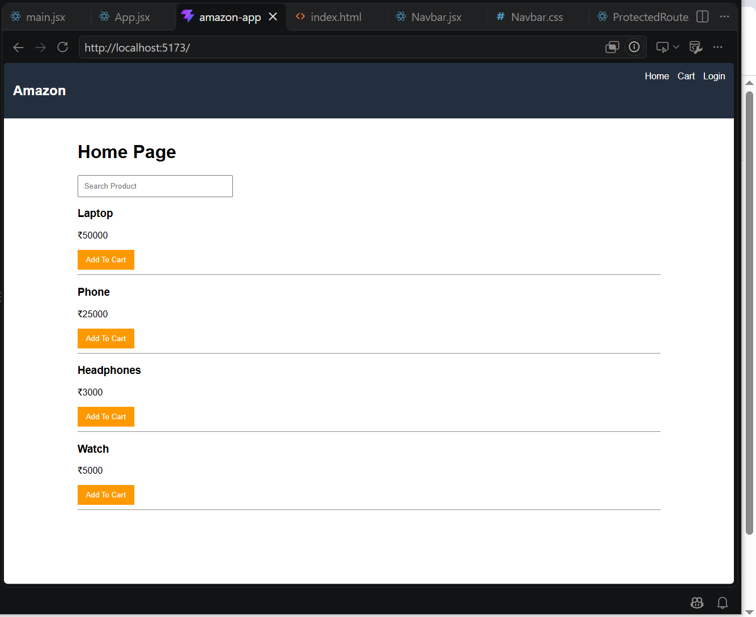
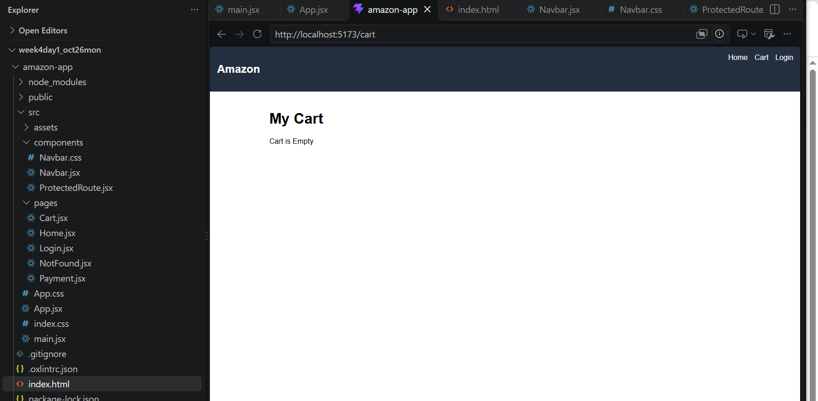
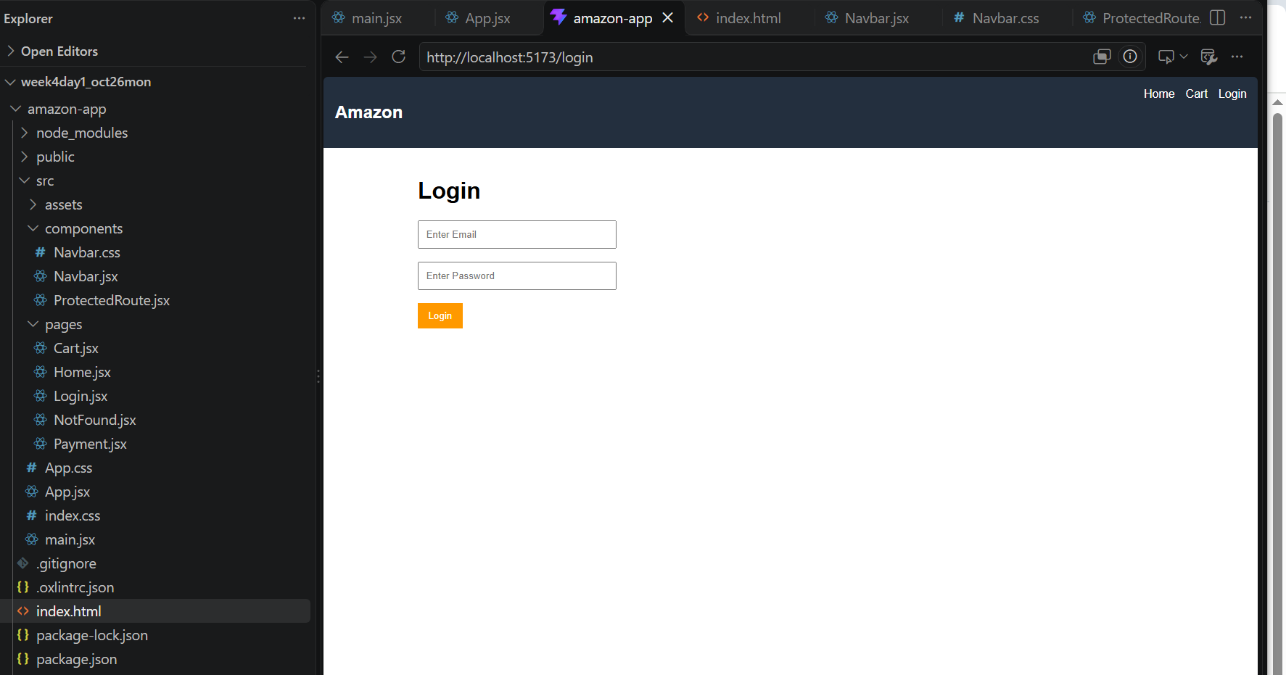
AFTER ADDING AN ITEM:
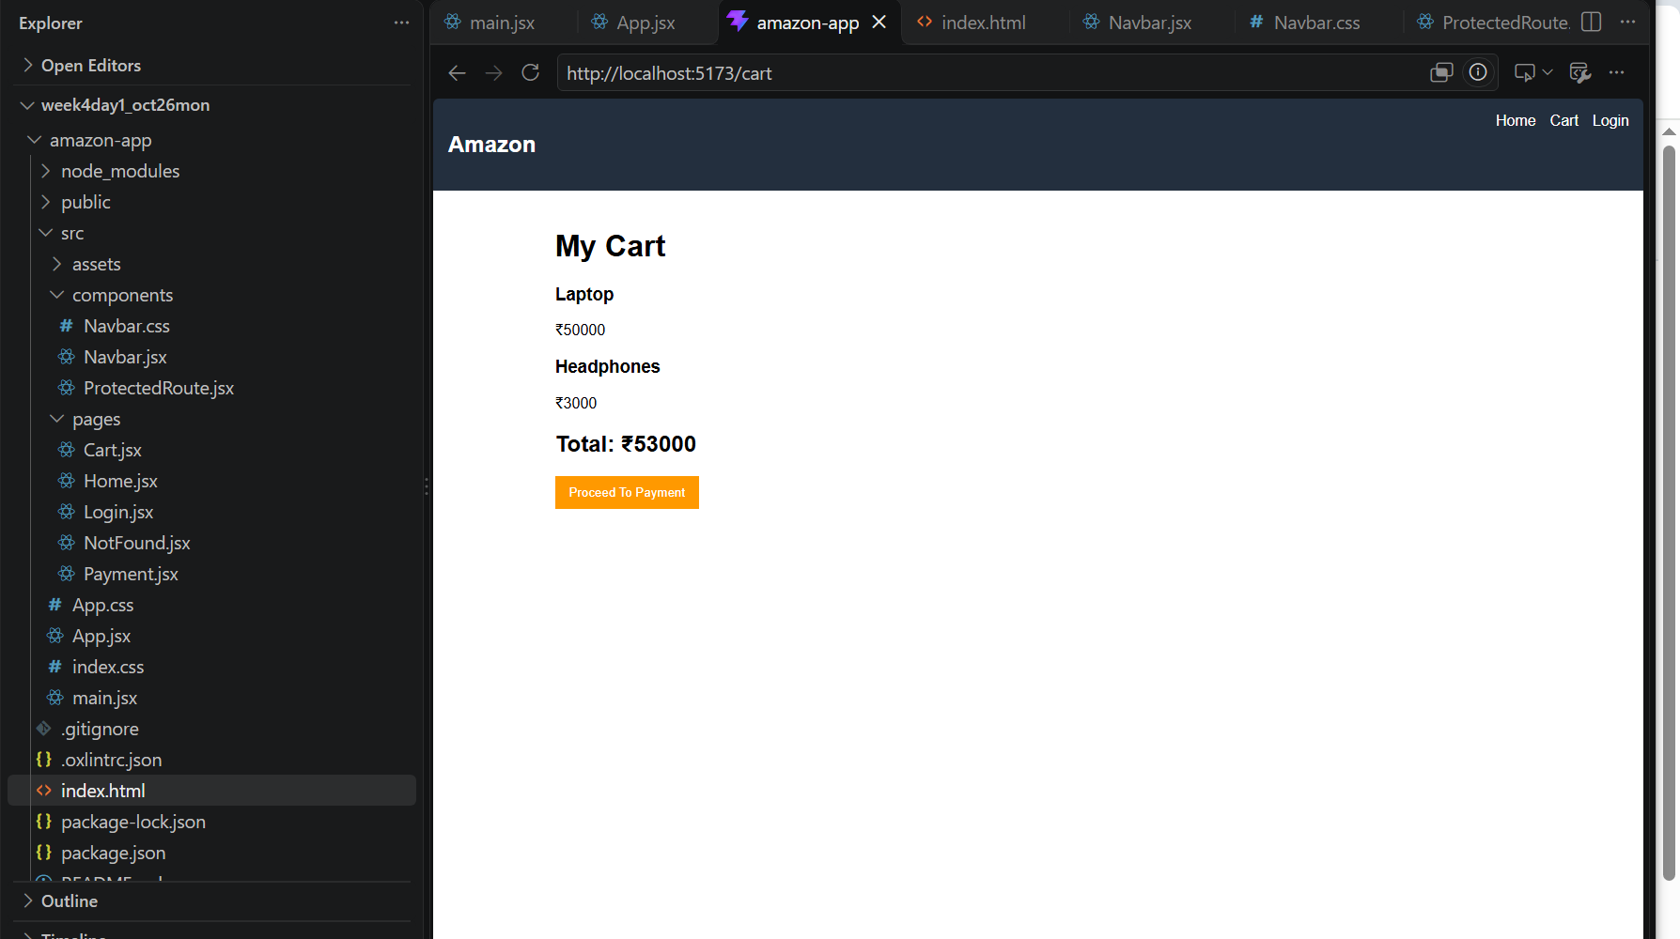
CLICKING ON PROCEED TO PAYMENT TAKES TO LOGIN PAGE
